RESOLUTION NO.__________

RE: CERTIFICATE OF APPROPRIATENESS UNDER THE
PROVISIONS OF THE ACT OF THE PENNSYLVANIA
LEGISLATURE 1961, JUNE 13, P.L. 282 (53
SECTION 8004) AND BETHLEHEM ORDINANCE NO.
3952 AS AMENDED.

WHEREAS, it is proposed to move the original letter and blade sign from the previous showroom to the present showroom at 119-123 E. Third Street.

NOW, THEREFORE, BE IT RESOLVED by the Council of the City of Bethlehem that a Certificate of Appropriateness is hereby granted for the work.

Sponsored by: (s)

(s)

ADOPTED BY COUNCIL THIS DAY OF

(s)
President of Council

ATTEST:

(s)
City Clerk

HISTORIC CONSERVATION COMMISSION

CASE # 604– It is proposed to move the original letter and blade sign from the previous showroom to the present showroom at 119-123 E. Third Street
OWNER/APPLICANT: East Allen Ventures / Keith Martin;Martin Furniture

The Commission upon motion by Mr. Lader seconded by Mr. Lousch adopted the proposal that City Council issue a Certificate of Appropriateness for the proposed work described herein:
- The proposal to move the original letter and blade sign from the previous showroom to the present showroom at 119-123 E. Third Street was represented by Keith Martin, Martin Furniture.

- The existing script style letters reading “Martins” will be slanted and slightly off center as already installed in the center panel of the storefront fascia.

- The existing block letters reading “FURNITURE” will be located in the center of the large panel to the left of center over the display window.

- New smaller (5” +/-) black composite letters will be added to the existing letter signs. “SOUTHSIDE” will be added to the “Martins” sign and “SINCE 1928” will be added “FURNITURE” sign. All letters will be upper case.

- Scaled shop drawings showing the size of the relocated and new lettered signs must be provided.

- The existing blade sign will be relocated in the small panel to the right of the entrance. This internally illuminated sign already located in the historic district is greater than 50 years old and therefore historic. For this reason it was permitted to remain internally illuminated.

- The motion to approve the proposal was unanimously approved.

CU: cu
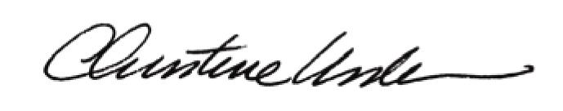

By:

Date of Meeting: January 23, 2017 Title: Historic Officer

